Nikeem Dunkelly-Allen, Thursday, Lab1

#include "library.h"

void seconds(const int m, const int h, const int d) {

print("Seconds in a minute: ");

print(m * m);

new_line();

print("Seconds in a day: ");

print(m * m * h);

new_line();

print("Seconds in a year: ");

print(m*m*h*d);

}  
Part A:

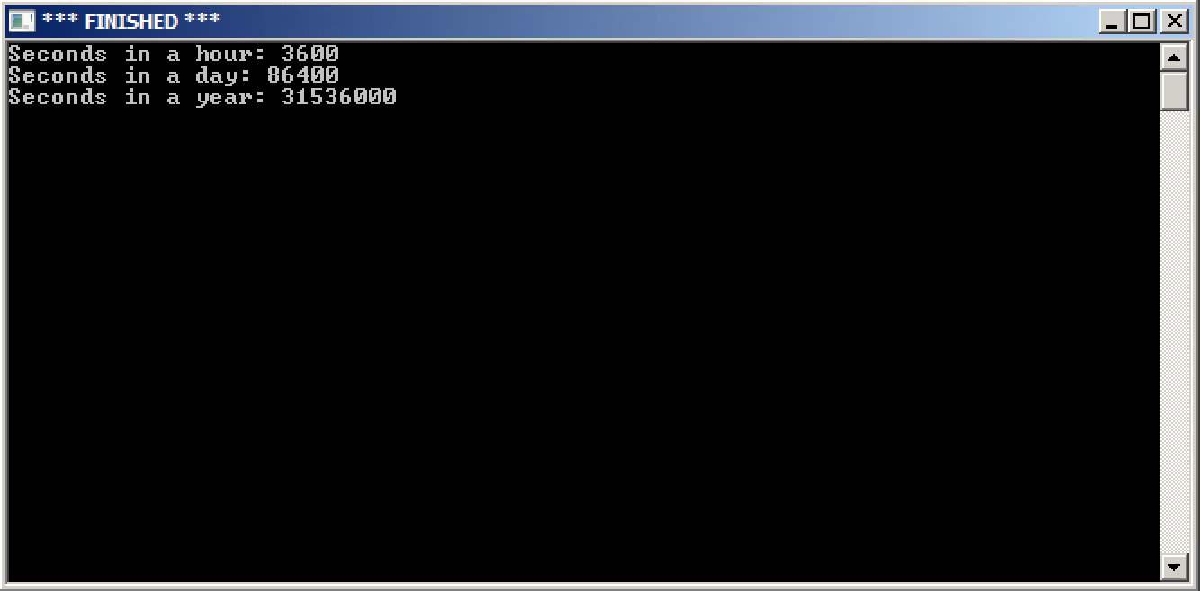

void draw_stars(){

move_to(200, 200);

draw_to(350, 200);

draw_to(275, 300);

draw_to(200, 200);

move_to(275, 175);

draw_to(200, 275);

draw_to(350, 275);

draw_to(275, 175);

}

Part B:

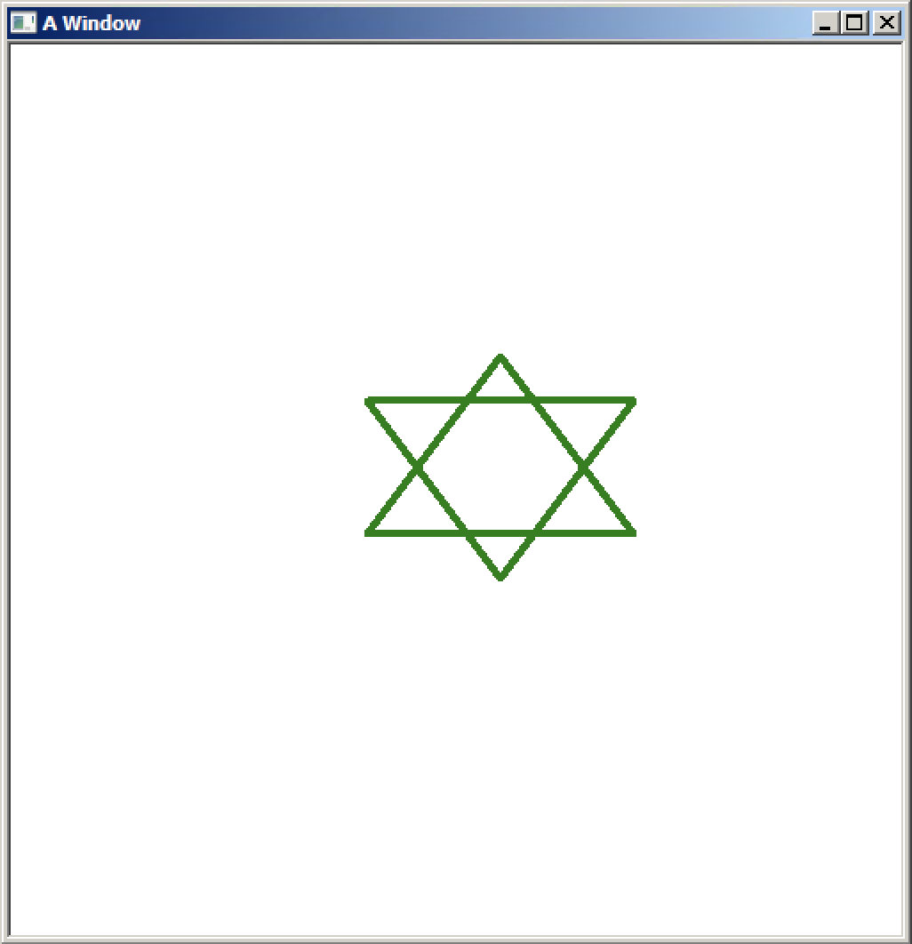

void draw_circle(const int x, const int y, const int n){

if (n > 0){

draw_distance(x);

turn_right_by_degrees(y);

draw_circle(x, y, n - 1);

}

}

void draw_stickman(){

move_to(255, 245);

draw_to(255, 400);

turn_left_by_degrees(135);

draw_distance(75);

move_to(255, 400);

set_heading_degrees(0);

turn_right_by_degrees(135);

draw_distance(75);

move_to(255, 323);

set_heading_degrees(0);

turn_right_by_degrees(45);

draw_distance(75);

}

Part C:

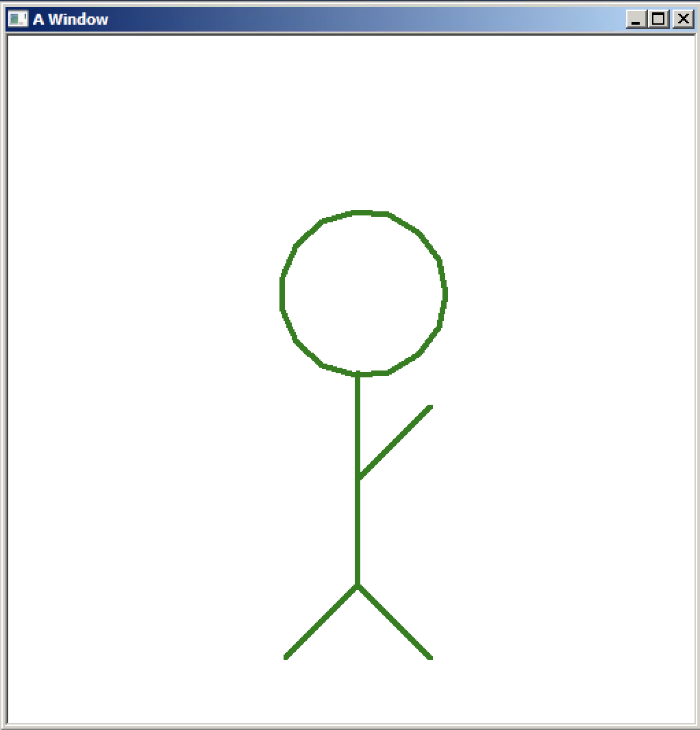

void main(){

seconds(60,24,365); - SECTION1/PART A

make_window(500, 500);

set_pen_width_color(4, color::dark_green);

move_to(200, 200);

draw_stars(); -SECTION 2/ PART C

draw_circle(25,24,15); - SECTION 3/ PART B

draw_stickman(); -SECTION 3/ PART B

}

WHEN RUNNING EACH PART PUT FUNCTIONS NOT RELATED TO THE SECTION IN COMMENTS